AIMS OF OUR SCHOOL
To foster an inclusive atmosphere conducive for learning and teaching which provides a breadth and balance of learning experiences that meets the needs of all children to promote independence.
To equip children with the skills, knowledge and positive character attitudes which will allow them to develop a joy for life and learning, confidence in themselves, resilience, patience and respect for others.
To work together to achieve and maintain high standards of behaviour, promoting an atmosphere of mutual respect, trust and understanding where all are valued and included.
To promote spiritual, ethical, moral, cultural, intellectual, personal and social development of all our pupils, ensuring well-being and celebrating diversity.
To provide a supportive and nurturing environment to develop pupils’ self-awareness and caring attitude, enabling them to value and develop responsibility for themselves, their families, relationships, society and the environment.
To achieve and maintain an inclusive climate of equal opportunity, developing individuals to aspire to and reach their full potential, in a safe, secure and engaging environment.
To involve and value children's contributions in a democratic, decision-making process that impacts upon their learning, personal development and their environment.
To strengthen partnerships between home, school and the wider community, including parents/carers as partners who are actively involved in their child's progress in development and learning.
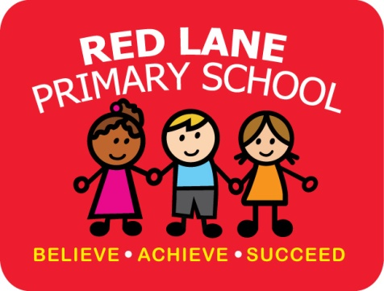
To prepare pupils as future citizens; preparing them to engage and persevere as individuals, parents, workers in society who embrace economic, social, cultural and technological change.

September 2021

