**Red Lane Primary School**

**Eco-Council Meeting Minutes (4)**

What was discussed?

Discussed the ordering of Eco Council badges – explained that Mrs Driver had given the ok and that the order had been submitted.

Meeting used as a workshop to add more details onto their ‘energy saving posters’.

Discussed (including visuals using interactive board) how saving power is good for the environment and looked at different types of power generation – renewable (wind, solar etc.) and non-renewable (coal, gas etc.).

Children designed a new Eco logo to go onto posters and documents within school.

Baylee McClarence’s design was chosen:

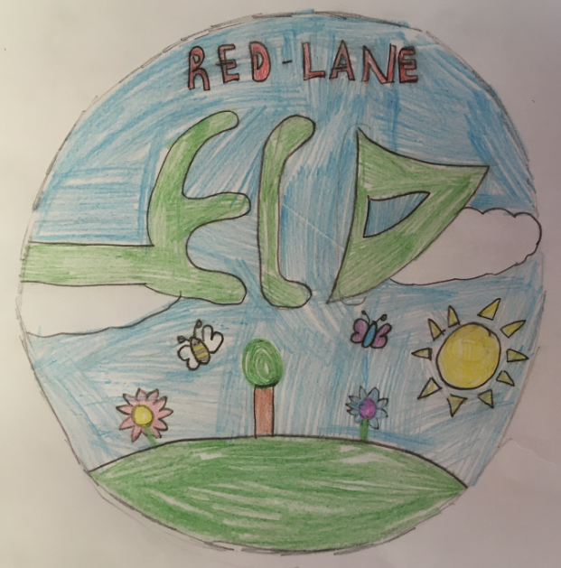

Time and date of the meeting:

17/03/2020

3:30pm-4:15pm (Location: 5S)

Eco-Committee members present:

* YR: Eliza Greenall
* Y1: Indie-Leigh Hartley
* Y2: Eliana Achioyamen
* Y4: Holly Hunter
* Y4: Baylee McClarence
* Staff: Mr Simmons
* Parent: Miss Griffiths

Eco-Committee members not present:

* Y3:Isabella Barnett
* Y5: Willow-Grace Hamilton
* Y6: Lucy Hunter (SATS booster)
* Y6: Emily Clark (SATS booster)
* Y6: Jessica Dean (SATS booster)
* SLT: Mrs Driver (emailed Minutes)

Next steps:

* Create classroom eco league criteria.
* Set up recycling / paper bins in class.
* Look into the possibility of having a bottle bin in school.
* IS to create ‘saving energy posters’ using children’s art and slogans; to be displayed throughout school (corridors and classrooms).

When and where is the next meeting?

Unknown – to arrange when schools re-open post-COVID-19.

