RED LANE PRIMARY SCHOOL
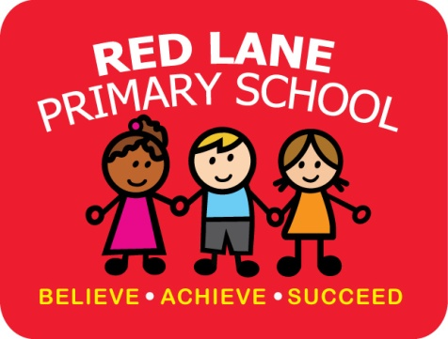
Red Lane, Bolton, BL2 5HP.
Tel: 01204 333 580 / Fax: 01204 333 579
office@red-lane.bolton.sch.uk
www.red-lane.bolton.sch.uk
Executive Headteacher: Mrs L Whittaker
Head of School: Mrs R Driver
Twitter: @RedLaneSch

9th November 2020

Dear Parents/Carers,

This is your child’s new reading pack, inside you will find three books. The first book is a paper version of the book your child will be reading in the daily phonics sessions, the second book is a follow on book linked to the first book. Both of these are books that your child can read to you throughout the week. The third book is a ‘storybook’, this is a book you can read to your child to help promote a love of reading.

Within school your child will read in a group each day in the phonics session, we will continue to read individually with children throughout the week.

Your child’s reading book will either be changed every three days or once a week, depending on the phonics group your child is in. The ‘storybook’ will be changed once a week.

We have invested time and money into our new Read Write Inc scheme, therefore there will be a £3 charge for lost books.

There is a live video showing these packs on the website. Later in the term we will be hosting online phonics and reading workshops, more information on these will be sent out soon.

Any questions please contact your child’s class teacher through class dojo.

Many thanks,
Miss Mellor
KS1 English Lead

