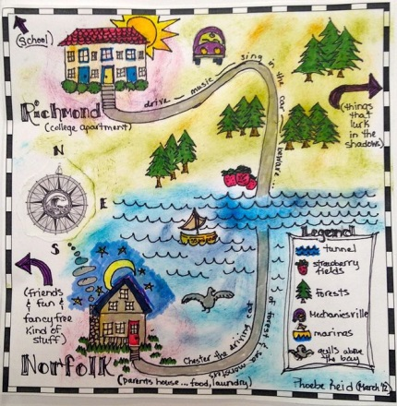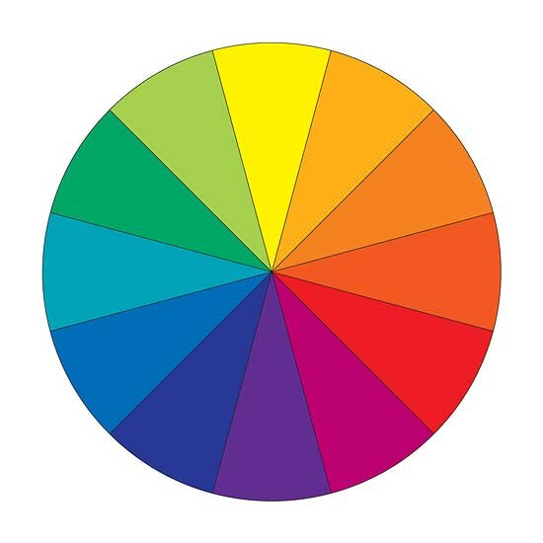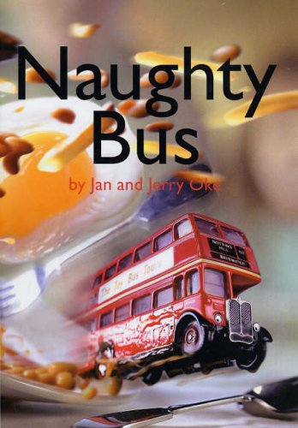

All projects (blue boxes) must be back in school for a celebration lesson in class on

**Wednesday 9th December 2020**

Remember the more home learning you do, the more Dojos you will achieve!

You could tweet us when you are working on your home learning **@redlanesch**

**Geography**

Draw a map of your route to school. Remember to include landmarks to help you find your way.

**Art**

Paint a picture of your house. Can you mix the colours you need using only red, blue and yellow?

**DT**

Make a model of The Naughty Bus.

**Project Tasks**

Knowledge Organiser Attached: **Our Local Area**

|  |  |
| --- | --- |
| **Week 1** | *Know and understand ‘The Big Idea’* |
| **Week 2** | *Know and understand ‘The Sticky Knowledge’* |
| **Week 3** | *Know and understand the first 6 pieces of ‘vocabulary’* |
| **Week 4** | *Know and understand the rest of the ‘vocabulary’ section* |
| **Week 5** | *Know any other information on the Knowledge Organiser* |
| **Week 6** | *Revise and consolidate learning.* |

**Weekly Spellings**

1 Dojo is awarded for scoring **at least** 4/6 on the weekly test.

**Weekly Maths task**

Use your Number Bonds booklet to keep practising your knowledge and increase your speed.

**Daily Reading**

Make sure this is recorded in your Reading Journal.

1 Dojo is awarded for every day that your child reads at home.

**Y1 Home Learning Menu**

**Autumn 2**