All projects (blue boxes) must be back in school for a celebration lesson in class on

**Wednesday 9th December 2020**

Remember the more home learning you do, the more Dojos you will achieve!

You could tweet us when you are working on your home learning **@RedLaneSch**

**History**

Create a map of Britain showing the different Viking areas and settlements that existed at the time. Where did they settle first? What were these areas called then and what are they called now? You can present this as creatively as you like, perhaps you could even use ICT.

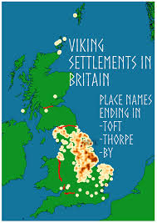

**Science**

Imagine you are a doctor who looks after people’s hearts. You are going to set up a ‘wellbeing’ clinic for children in primary school. In this clinic they will need to be able to provide advice as to how to live a healthy life. You need produce a leaflet that children can take away with them that tells them how to stay healthy. Your leaflet should include information about exercise, lifestyle, diet and drugs (including medicines, alcohol, tobacco and illegal drugs).

**DT**

Design and create a 3D model of your own Viking shield!

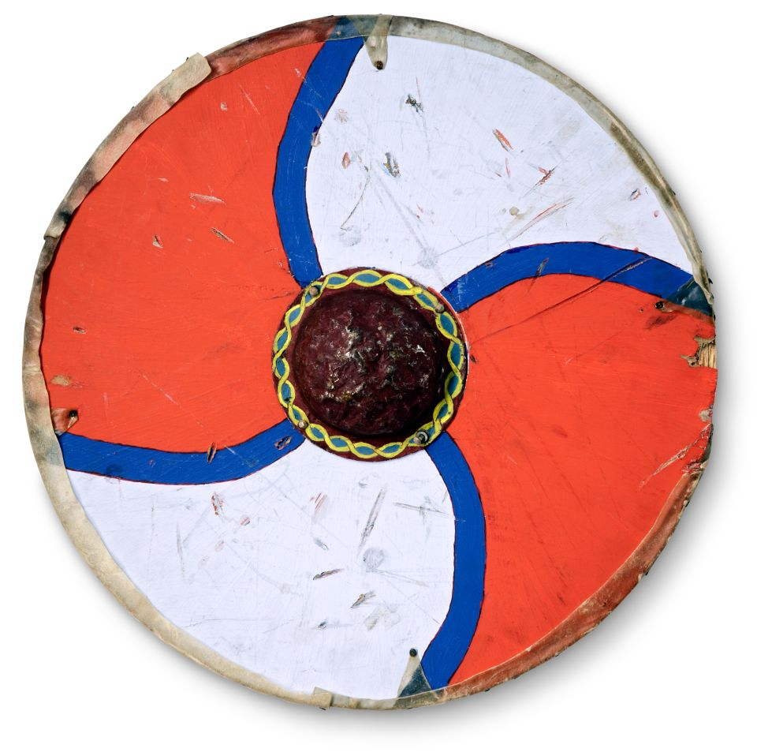

**Project Tasks**

Knowledge Organiser Attached: **Vikings**

|  |  |
| --- | --- |
| **Week 1** | *Know and understand ‘The Big Idea’* |
| **Week 2** | *Know and understand ‘The Sticky Knowledge’* |
| **Week 3** | *Know and understand the first 6 pieces of ‘vocabulary’* |
| **Week 4** | *Know and understand the rest of the ‘vocabulary’ section* |
| **Week 5** | *Know any other information on the Knowledge Organiser* |
| **Week 6** | *Revise and consolidate learning.* |

**Weekly Spellings**

1 Dojo is awarded for scoring **at least** 12/15 on the weekly test.

**Weekly Maths task**

This will be sent each week. Use TT Rockstars to practise your times tables

**Daily Reading**

Make sure this is recorded in your Reading Journal

1 Dojo is scored for reading each day. If 5 out of 5, extra Dojos will be rewarded.p

**Y6 Home Learning Menu**

**Autumn 2**