All projects (blue boxes) must be back in school for a celebration lesson in class on

**Wednesday 9th December 2020**

Remember the more you home learning you do, the more Dojos you will achieve!

You could tweet us when you are working on your home learning **@redlanesch**

**Geography**

Research facts about and create a presentation on one of the world’s famous rivers.

Example Rivers:

* The Thames
* The Seine
* The Amazon
* The Nile
* The Ganges
* The Mississippi

Include physical characteristics such as length and major cities build on them.

**Art**

Draw or paint and the scene from one of the world’s famous rivers.

[](https://www.google.co.uk/url?sa=i&url=https%3A%2F%2Fwww.artpal.com%2Fbuy%2Fpaintings-prints%2Fplaces-travel%2Feurope%2Fitaly%2F%3Fi%3D868-71&psig=AOvVaw1EwHvPLwvHStWEjEICx-yM&ust=1602101856985000&source=images&cd=vfe&ved=0CAIQjRxqFwoTCPiriNbkoOwCFQAAAAAdAAAAABAD)

 (Above example: The Tiber, Rome)

**DT (Modelling)**

Create a labelled model of a river from source to mouth.

[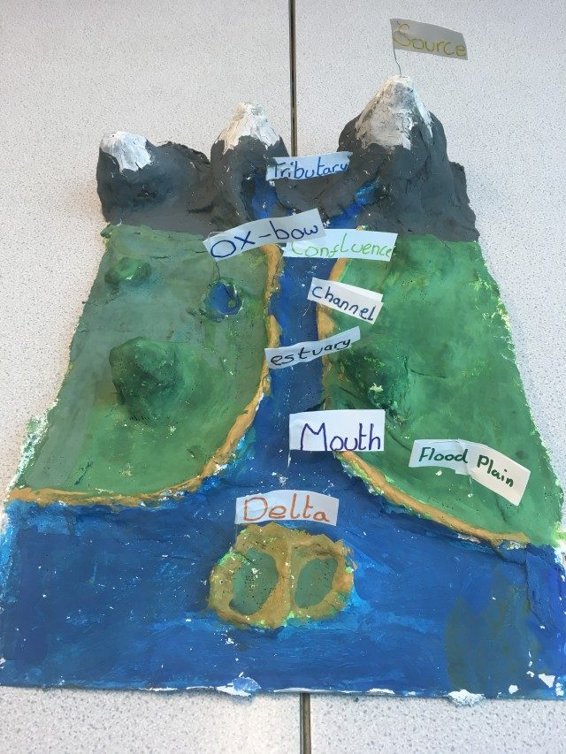](https://www.google.co.uk/url?sa=i&url=https%3A%2F%2Fwww.wensumjunior.co.uk%2F2018%2F05%2Fmonday-21st-may-3d-river-system-models%2F&psig=AOvVaw3bnvIqcocDOwcZzWAnxjUc&ust=1602101574467000&source=images&cd=vfe&ved=0CAIQjRxqFwoTCPCGvdXjoOwCFQAAAAAdAAAAABAD)

**Project Tasks**

Knowledge Organiser Attached: **Rivers**

|  |  |
| --- | --- |
| **Week 1** | *Know and understand ‘The Big Idea’* |
| **Week 2** | *Know and understand ‘The Sticky Knowledge’* |
| **Week 3** | *Know and understand the first 6 pieces of ‘vocabulary’* |
| **Week 4** | *Know and understand the rest of the ‘vocabulary’ section* |
| **Week 5** | *Know any other information on the Knowledge Organiser* |
| **Week 6** | *Revise and consolidate learning.* |

**Weekly Spellings**

1 Dojo is awarded for scoring **at least** 7/10 on the weekly test.

**Weekly Maths task**

This will be sent each week. Use TT Rockstars to practise your times tables

**Daily Reading**

Make sure this is recorded in your Reading Journal

1 Dojo is scored for reading **at least** 4 out of 5 days a week at home.

**Y4 Home Learning Menu**

**Autumn 2**