All projects (blue boxes) must be back in school for a celebration lesson in class on

**Wednesday 9th December 2020**

Remember the more you home learning you do, the more Dojos you will achieve!

You could tweet us when you are working on your home learning **@redlanesch**

**Geography**

Find out the names of the seven kingdoms of Anglo Saxon Britain- can you find out more about one of them?

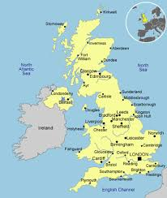

**Art**

Use your sketching skills to recreate some Anglo Saxon jewellery

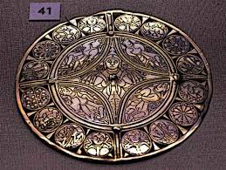

**DT**

Design and make an Anglo Saxon shield

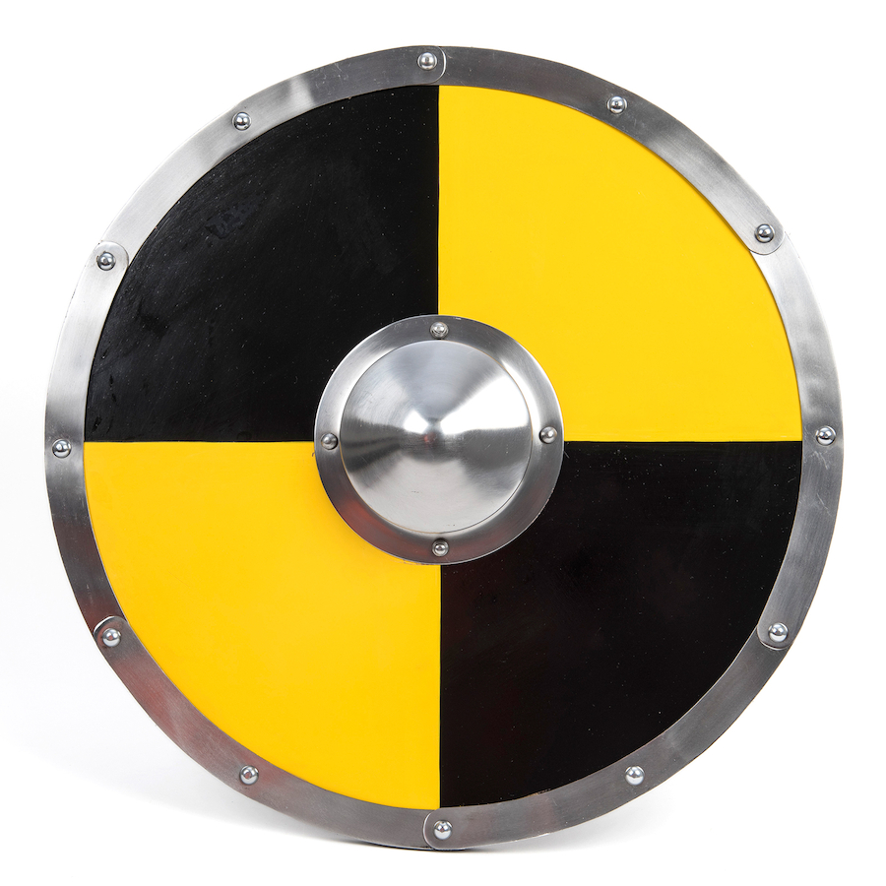

**Project Tasks**

Knowledge Organiser Attached: **Anglo Saxons**

|  |  |
| --- | --- |
| **Week 1** | *Know and understand ‘The Big Idea’* |
| **Week 2** | *Know and understand ‘The Sticky Knowledge’* |
| **Week 3** | *Know and understand the first 6 pieces of ‘vocabulary’* |
| **Week 4** | *Know and understand the rest of the ‘vocabulary’ section* |
| **Week 5** | *Know any other information on the Knowledge Organiser* |
| **Week 6** | *Revise and consolidate learning.* |

**Weekly Spellings**

1 Dojo is awarded for scoring **at least** 7/10 on the weekly test.

**Weekly Maths task**

This will be sent each week. Use TT Rockstars to practise your times tables

**Daily Reading**

Make sure this is recorded in your Reading Journal

1 Dojo is scored for reading **at least** 4 out of 5 days a week at home.

**Y5 Home Learning Menu**

**Autumn 2**