The Punctuation Thief Strikes Again
Guidance:
Read the text, search for any unknown vocabulary using a dictionary or search engine, then answer the questions at the bottom of the page. Use evidence from the text to support your answers.
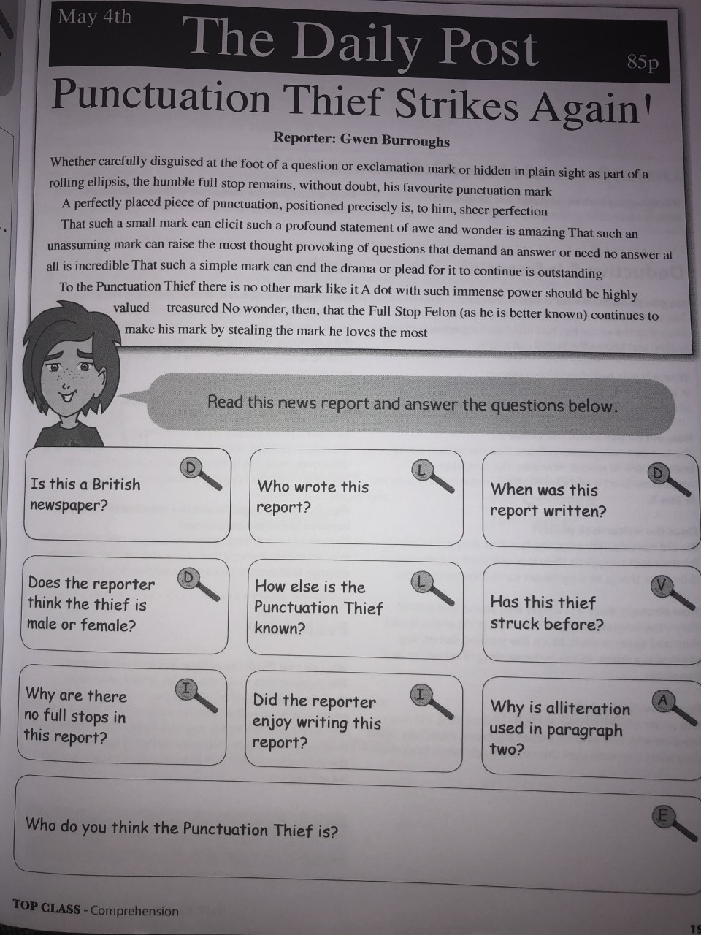
- Is this a British newspaper?

- Who wrote this report?

- When was this report written?

- Does the reporter think the thief is male or female?

- How else is the Punctuation Thief known?

- Has this thief struck before?

- Why are there no full stops in this report?

- Did the reporter enjoy writing this report?

- Why is alliteration used in paragraph two?

