Observe, Infer, Wonder, Predict
Infer
Who do you think these people are? Who is the woman in black? Use clues in the picture to explain your thoughts.
Observe
What can you see? Look at the picture and write about what you can see.
Observe
What can you see? Look at the picture and write about what you can see.
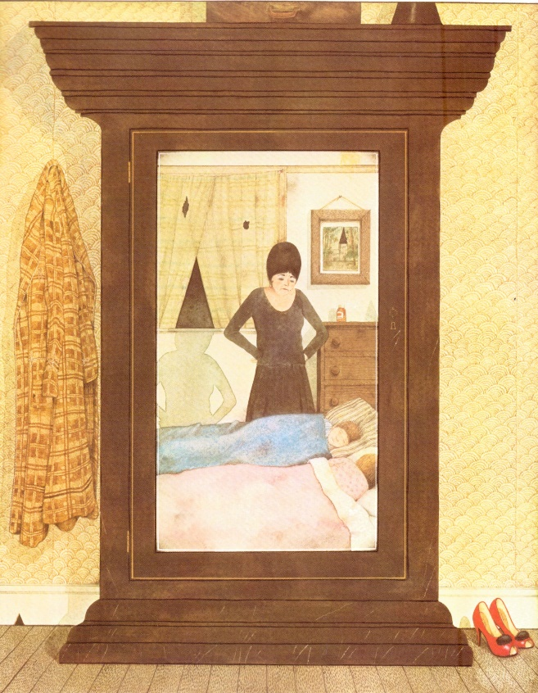
Predict
Based on the information you have gathered from the picture, what do you think will happen next in this story?
Wonder
What does this image make you think? Are there any questions that you would ask the characters? Does this remind you of any other stories you know?

