Stop Thief
Guidance:
Read the text, search for any unknown vocabulary using a dictionary or search engine, then answer the questions at the bottom of the page. Use evidence from the text to support your answers.
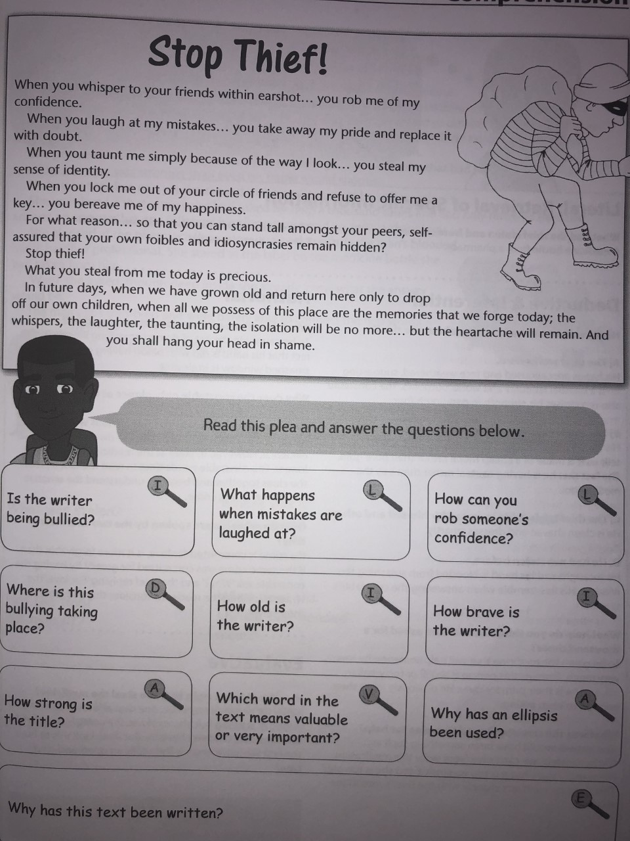
- Is the writer being bullied?

- What happens when mistakes are laughed at?

- How can you rob someone’s confidence?

- Where is the bullying taking place?

- How old is the writer?

- How brave is the writer?

- How strong is the title?

- Which word in the text means valuable or very important?

- Why has an ellipsis been used?

